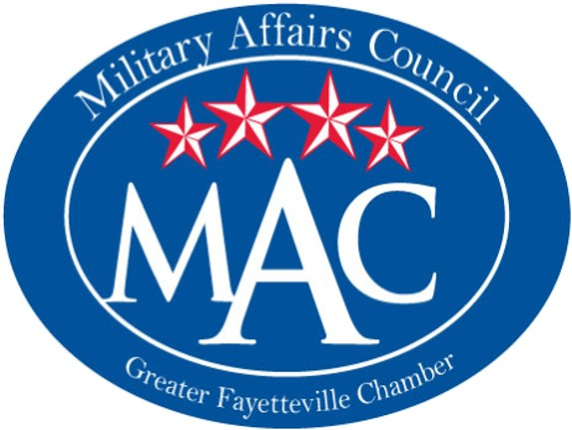
Spouses in Military (SiM) Conference
Thursday, Nov. 8, 2018
9AM – 3PM
Kiwanis Rec Center, Fayetteville, NC

Purpose: To provide a program for military spouses which will acquaint them with the Fayetteville/Cumberland area and its offerings; and offer a motivational luncheon speaker to promote self-esteem and encouragement.
Business and Non-Profit Expo – Military spouses (male or female) can come at any point throughout the day to visit display booths of local restaurants and retailers to learn about their products and services. Booths will need to offer coupons, free samples and/or giveaways. There will also be an area for non-profit resources such as education, social services, healthcare, workforce development and other resources available to them.
We can accommodate 300 or more spouses, and we’re requesting they pre-register when possible for an accurate count to expect. We hope this will be the first of an annual program, which could expand into workshops and break-out sessions in future years. Reserve your booth today!
REGISTRATION: Booth space is limited and secured by a completed reservation form and payment. Vendor Forms and payment must be submitted at least two weeks prior to the event to Events@FayBiz.com or mail to 159 Maxwell Street, Fayetteville, NC 28301.
Company _____________________________________________________
Contact Person ________________________________________________
Address ______________________________________________________
Program helps support the USO of North Carolina
Sandhills Chapter Spouse’s Reset Program
Contact Phone ______________________ Contact Email ________________________
Description of products or services being promoted
____________________________________________________________________________________________________________________________________________________________________________________________________

Pricing for 6-foot table and 2 chairs:
$150 – MAC Member
$250 – Chamber Member
$350 – Non-Chamber Member
$75 – Food booths with samples
FREE – Non-profit/educational/government agency booths, LIMITED NUMBER AVAILABLE!!!
Total Amount Submitted______________

Check # _________
Visa/MasterCard/Discover/AmEx
_______________________________
Exp. Date: _________
CWV: _______

The Greater Fayetteville Chamber or their affiliates will not be held responsible for any liability, lost, stolen or damaged merchandise or any injury incurred during the Conference.
Signature of Vendor___________________________ Date ________________________

